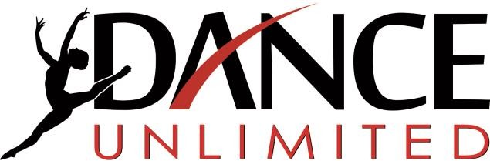
11489 Fairview Ave. Boise, Idaho 83713
(208) 322-8082  www.danceunlimitedstudios.com

2022-2023
Competition Team Sponsor Form

We are Dance Unlimited, a dance studio, located in west Boise, very near Meridian. We have been teaching and training dancers for over 30 years. Our award-winning competition dance teams perform nearly 15 times per year at basketball games, high school drill team spring shows, competitions, community events, etc. Thanks to the generous donations of sponsors like you, our Competition Teams can experience dance events such as: bringing to Boise professional dancers and choreographers from all around the nation to teach & train our dancers, attending local and out of state conventions & competitions including Radix, Spotlight, Hollywood Vibe, etc. and participation in many performances at community events. These dance opportunities provide valuable experience which helps our advanced students become better dancers, performers, and assets to the community.
To help us to participate in the above-mentioned dance activities, we are seeking sponsors from the local community. In thanks for your generous donations, we will offer you the following advertising:
$100 Silver Donation: Your Company will be listed as a generous donor, in BOTH of our dance recital printed programs: in December at both of our Christmas Dance Recitals and in May at both of our Spring Dance Recitals. Attendance at each recital exceeds 1000 people.
$200 Gold Donation: In addition to being listed in our printed programs, your business name will be screen-printed on the back of our T-shirts. Over 120 dancers will wear those T-shirt all year. YOUR business name will be seen as these shirts are worn to dance competitions, dance class, school, ball games, the grocery store, etc. as we live and work in this community.
$300+ Platinum donation: In addition to all that is listed above, your business name will be printed on a banner which will hang in our studio. Considering that over 800 people pass through our studio each week, that is great publicity for your business.

- - - - - - - - - - - - - - - - - - - - - - - - - - - -- - - - - - - -cut here - - - - - - - - - - - - - - - - - - - - - - - - - - - - - - - - - - - - - -
Your business name, as you would like it to appear: Your donation amount $ .
Are you sponsoring an individual dancer? (If so, her name)
OR Are you sponsoring the teams? (If so, put an X here)
Please make your check payable to “DANCE UNLIMITED PDA.”
If sponsoring an individual dancer, please write her name on the bottom of your check.
Please give your sponsor check directly to your dancer or mail it to our studio. The address is listed at the top of this page.

THANK YOU so much for being a Dance Unlimited Sponsor!

